A

PROJECT SYNOPSIS

on

***Solar Agricultural Water Pumping System with Auto Tracking and Sensors***

DEPARTMENT OF ELECTRICAL ENGINEERING

Prescribed by **Dr. Babasaheb Ambedkar Technological University, Lonere**



Submitted by

Under the Guidance OF

**Prof.S.Y.KAMDI**

**MR .AJIT.Y.RAIPURE**

**MISS.DIVYA .B.PADDIWAR**

**MR.SWAPNIL .B.MADAVI**

**MR.PRATAP.D.GHARAT**

**RAJIV GANDHI COLLEGE OF ENGINEERING, RESEARCH AND TECHNOLOGY, CHANDRAPUR**

**2021-2022**

**DEPARTMENT OF ELECTRICAL ENGINEERING**

**RAJIV GANDHI COLLEGE OF ENGINEERING, RESEARCH AND TECHNOLOGY, CHANDRAPUR**

**CERTIFICATE**

*This is to certify that this project entitled* ***Solar Agricultural Water Pumping System with Auto Tracking and Sensors***



SUBMITTED BY

**MR .AJIT.Y.RAIPURE**

**MISS.DIVYA .B .PADDIWAR**

**MR.SWAPNIL .B .MADAVI**

**MR.PRATAP .D.GHARAT**

**Abstract**

Agricultural technology is changing rapidly. Farm machinery, farm building and production facilities are constantly being improved. Agricultural applications suitable for photovoltaic (PV) solutions are numerous. These applications are a mix of individual installations and systems installed by utility companies when they have found that a PV solution is the best solution for remote agricultural need such as water pumping for crops or livestock. A solar powered water pumping system is made up of two basic components. These are PV panels and pumps. The smallest element of a PV panel is the solar cell. Each solar cell has two or more specially prepared layers of semiconductor material that produce direct current (DC) electricity when exposed to light. This DC current is collected by the wiring in the panel. It is then supplied either to a DC pump, which in turn pumps water whenever the sun shines ,or stored in batteries for later use by the pump. The aim of this article is to explain how solar powered water pumping system works and what the differences with the other energy sources are.

**INTRODUCTION**

It is common to use diesel to power generators in agricultural operations. While these systems can provide power where needed there are some significant drawbacks, including:

• Fuel has to be transported to the generator’s location, which may be quite a distance over some challenging roads and landscape.

• Their noise and fumes can disturb livestock.

• Fuel costs add up, and spills can contaminate the land.

• Generators require a significant amount of maintenance and, like all mechanical systems, they break down and need replacement parts that are not always available.

There are also major disadvantages in using propane or bottled gas to heat water for pen cleaning or in crop processing applications, or to heat air for crop drying, including transportation to the location where you need the heat, costs of fuel and safety issues. For many agricultural needs, the alternative is solar energy. Modern, well-designed, simple to maintain solar systems can provide the energy that is needed where it is needed, and when it is needed. These are systems that have been tested and proven around the world to be cost-effective and reliable, and they are already raising levels of agricultural productivity worldwide. Fig. 1 A range and solar system are side by side In general, there are two types of solar systems – those that convert solar energy to D.C. power and those that convert solar energy to heat. Both types have many applications in agricultural settings, making life easier and helping to increase the operation’s productivity. First is solar generated electricity, called photovoltaic (or PV). Photovoltaic are solar cells that convert sunlight to D.C. electricity. The solar cells in a PV module are made from semiconductor materials. When light energy strikes the cell, electrons are knocked loose from the material’s atoms. Electrical conductors attached to the positive and negative sides of the material allow the electrons to be captured in the form of a D.C. current. This electricity can then be used to power a load, such as a water pump, or it can be stored in a battery. It’s a simple fact that PV modules produce electricity only when the sun is shining, so some form of energy storage is necessary to operate systems at night. You can store the energy as water by pumping it into a tank while the sun is shining and distributing it by gravity when it’s needed after dark. For electrical applications at night, you will need a battery to store the energy generated during the day. Photovoltaic is a well-established, proven technology with a substantial international industry network. And PV is increasingly more cost-effective compared with either extending the electrical grid or using generators in remote locations. The cost per peak watt of today’s PV power is about $7. Local supply conditions, including shipping costs and import duties, vary and may add to the cost.

**Objectives**

Objectives of the project are mentioned following:

1. To design an automatic system for Irrigation.
2. To bring an easier way for our Irrigation system.
3. To minimize the cost
4. To save the fuels
5. Easy to operate
6. To reduce the pressure from grid electricity

**Literature Review**

**Technology of Solar Panel**

Solar panels are devices that convert light into electricity. They are called solar after the sun because the sun is the most powerful source of the light available for use. They are sometimes called photovoltaic which means "light-electricity". Solar cells or PV cells rely on the photovoltaic effect to absorb the energy of the sun and cause current to flow between two oppositely charge layers.A solar panel is a collection of solar cells. Although each solar cell provides a relatively small amount of power, many solar cells spread over a large area can provide enough power to be useful. To get the most power, solar panels have to be pointed directly at the Sun.The development of solar cell technology begins with 1839 research of French physicist Antoine-Cesar Becquerel. He observed the photovoltaic effect while experimenting with a solid electrode in an electrolyte solution. After that he saw a voltage developed when light fell upon the electrode.

According to Encyclopaedia Britannica the first genuine for solar panel was built around 1883 by Charles Fritts. He used junctions formed by coating selenium (a semiconductor) with an extremely thin layer of gold. Crystalline silicon and gallium arsenide are typical choices of materials for solar panels. Gallium arsenide crystals are grown especially for photovoltaic use, but silicon crystals are available in less-expensive standard ingots, which are produced mainly for consumption in the microelectronics industry. Norway’s Renewable Energy Corporation has confirmed that it will build a solar manufacturing plant in Singapore by 2010 - the largest in the world. This plant will be able to produce products that can generate up to 1.5 Giga wattsof energy every year. That is enough to power several million households at any one time. Last year the world as a whole produced products that could generate just 2 GW in total.

**Evolution of Solar Tracker**

Since the sun moves across the sky throughout the day, in order to receive the best angle of exposure to sunlight for collection energy. A tracking mechanism is often incorporated into the solar arrays to keep the array pointed towards the sun. A solar tracker is a device onto which solar panels are fitted which tracks the motion of the sun across the sky ensuring that the maximum amount of sunlight strikes the panels throughout the day. When compare to the price of the PV solar panels, the cost of a solar tracker is relatively low. Most photovoltaic solar panels are fitted in a fixed location- for example on the sloping roof of a house, or on framework fixed to the ground. Since the sun moves across the sky though the day, this is far from an ideal solution. Solar panels are usually set up to be in full direct sunshine at the middle of the day facing South in the Northern Hemisphere, or North in the Southern Hemisphere. Therefore morning and evening sunlight hits the panels at an acute angle reducing the total amount of electricity which can be generated each day.

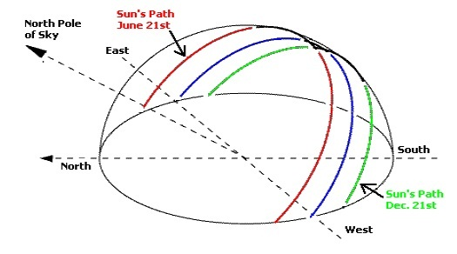

Fig 2.1 Sun’s apparent motion

During the day the sun appears to move across the sky from left to right and up and down above the horizon from sunrise to noon to sunset. Figure 2.1 shows the schematic above of the Sun's apparent motion as seen from the Northern Hemisphere.To keep up with other green energies, the solar cell market has to be as efficient as possible in order not to lose market shares on the global energy marketplace. The end-user will prefer the tracking solution rather than a fixed ground system to increase their earnings because:

* The efficiency increases by 30-40%.
* The space requirement for a solar park is reduced, and they keep the same output.
* The return of the investment timeline is reduced.
* The tracking system amortizes itself within 4 years.
* In terms of cost per Watt of the completed solar system, it is usually cheaper to use a solar tracker and less solar panels where space andplanning permit.
* A good solar tracker can typically lead to an increase in electricity generation capacity of 30-50%.

**Block Diagram**

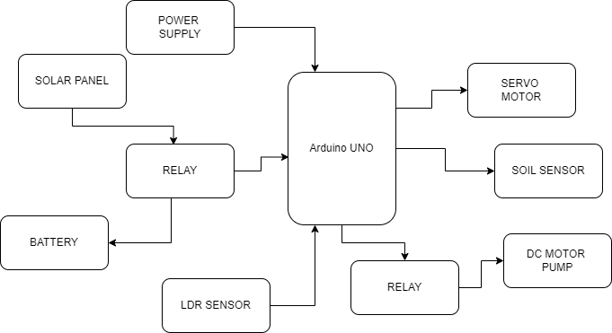

**Working –**

**We are using Arduino uno as micro controller. Battery will be charged by using solar panel. Ldr will detect the intensity of solar power. Servo motor is used for scarecrow which will make sure to keep bird away from farm. Soil sensor will detect the condition of soil and switch on and off the motor pump using electromagnetic relay.**

**Component List**

1. Arduino UNO
2. Solar Panel
3. LDR Sensor
4. Lead acid battery
5. DC motor pump
6. Soil sensor
7. MG996R servo motor
8. Copper Plate
9. Resistor
10. Led
11. Capacitor
12. Female power jack
13. Led
14. Arduino UNO
15. 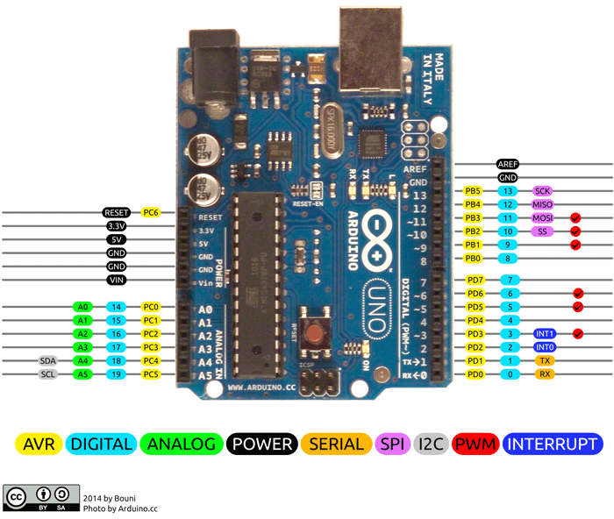
16. **Arduino Uno Pinout**
17. **Arduino Uno** is a popular microcontroller development board based on 8-bit [ATmega328P](https://components101.com/microcontrollers/atmega328p-pinout-features-datasheet) microcontroller. Along with ATmega328P MCU IC, it consists other components such as crystal oscillator, serial communication, voltage regulator, etc. to support the microcontroller.
19. **Arduino Uno Pinout Configuration**

|  |  |  |
| --- | --- | --- |
| **Pin Category** | **Pin Name** | **Details** |
| Power | Vin, 3.3V, 5V, GND | Vin: Input voltage to Arduino when using an external power source.  5V: Regulated power supply used to power microcontroller and other components on the board.  3.3V: 3.3V supply generated by on-board voltage regulator. Maximum current draw is 50mA.  GND: ground pins. |
| Reset | Reset | Resets the microcontroller. |
| Analog Pins | A0 – A5 | Used to provide analog input in the range of 0-5V |
| Input/Output Pins | Digital Pins 0 - 13 | Can be used as input or output pins. |
| Serial | 0(Rx), 1(Tx) | Used to receive and transmit TTL serial data. |
| External Interrupts | 2, 3 | To trigger an interrupt. |
| PWM | 3, 5, 6, 9, 11 | Provides 8-bit PWM output. |
| SPI | 10 (SS), 11 (MOSI), 12 (MISO) and 13 (SCK) | Used for SPI communication. |
| Inbuilt LED | 13 | To turn on the inbuilt LED. |
| TWI | A4 (SDA), A5 (SCA) | Used for TWI communication. |
| AREF | AREF | To provide reference voltage for input voltage. |

2. **Arduino Uno Technical Specifications**

|  |  |
| --- | --- |
| Microcontroller | ATmega328P – 8 bit AVR family microcontroller |
| Operating Voltage | 5V |
| Recommended Input Voltage | 7-12V |
| Input Voltage Limits | 6-20V |
| Analog Input Pins | 6 (A0 – A5) |
| Digital I/O Pins | 14 (Out of which 6 provide PWM output) |
| DC Current on I/O Pins | 40 mA |
| DC Current on 3.3V Pin | 50 mA |
| Flash Memory | 32 KB (0.5 KB is used for Bootloader) |
| SRAM | 2 KB |
| EEPROM | 1 KB |
| Frequency (Clock Speed) | 16 MHz |

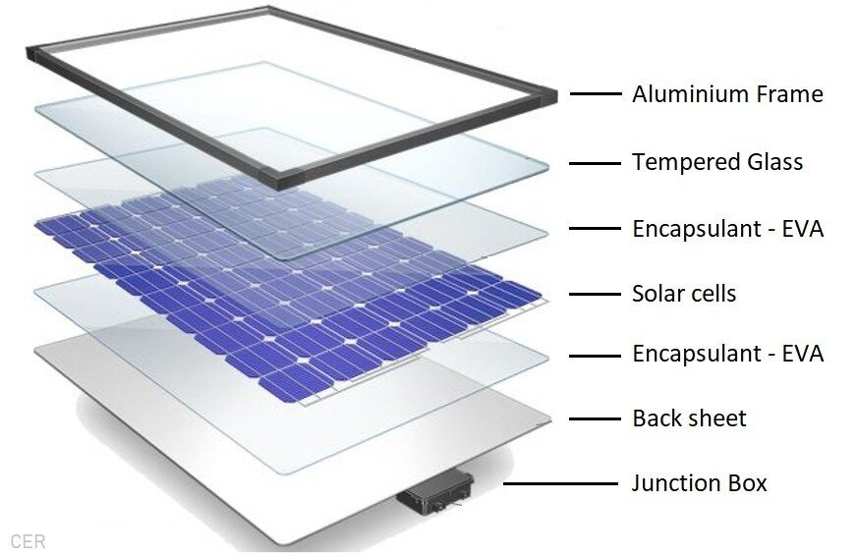

Solar energy, as a renewable energy, is the direct solar energy conversion and utilization. Solar radiation conversion device converts energy use which belongs to solar thermal technology, the recycling heat energy is called solar thermal power generation, it also belongs to this technology area; solar radiation conversion device converts energy utilization is solar power generation technology, photoelectric conversion device usually uses the photoelectric conversion semiconductor devices, via the photovoltaic effect principle, also known as solar photovoltaic technology, and so appears a solar power system of grid and off grid solar power system. In the 1950s, there are two major technological breakthroughs in the field of solar energy utilization: one is the utility-type monocrystalline silicon cells, and the second is the 1955 Israel Tabor selective put forward the concepts and theories and the successful development of selective solar absorbing coating. These two technological breakthroughs laid the technical foundation for the use of solar energy into the modern period of development.

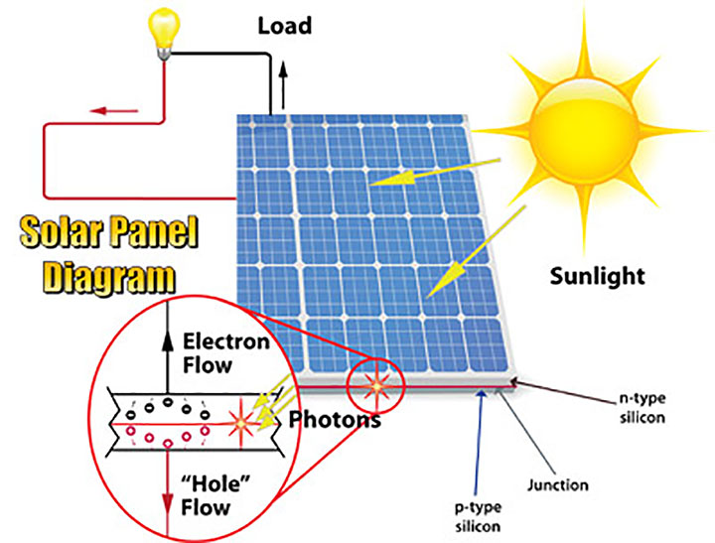

Choice of Solar Panels

The so-called output power of the solar cell we said is Wp under a standard solar light condition, namely: 101 standard of the European Commission defined radiation intensity 1000W/m2, air quality AM1.5, a battery temperature of 25 °C under the conditions of the solar cell output power. The solar panels 500w are suitable for many families with the standard configuration. This condition is about and usually sunny day around noon sunlight conditions almost, this is not just as some people imagine, as long as there is sunshine, there will be a rated output power, even solar cells under fluorescent lights at night can also be used normally. This means that the output power of the solar cell is random, at different times, in different locations, the same piece of the output power of the solar cell is different.

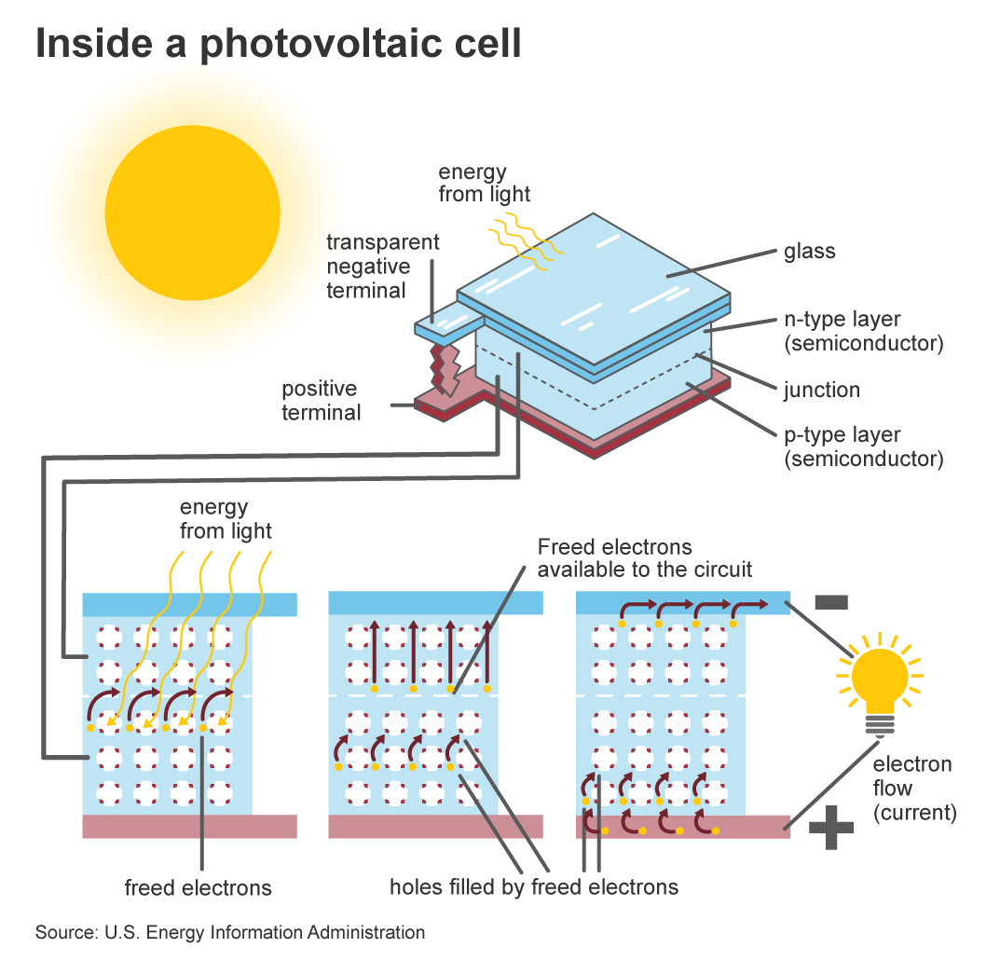

Characteristics of the Solar Panels

Solar panels are a huge PN junction, which convert solar energy into electricity. As for the monolithic solar battery, it is a small PN junction, in addition to when the sunlight in the above, it can generate electricity, further having all the characteristics of the PN junction. In standard light conditions, its rated output voltage is 0.48V. The solar cell module use of solar lighting is connected by the multi-plate solar cell constituted. It has a negative temperature

coefficient, and the temperature rises for each degree, the voltage drops 2mV. In use, the open or short circuit of the solar cell is not to be damaged, in fact we also took advantage of this characteristic of the system battery charge and discharge control.

LDR

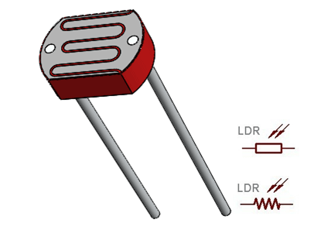

The **Light Dependent Resistor** (**LDR**) or also popularly known as Photoresistor is just another special type of Resistor and hence has no polarity so they can be connected in any direction. They are breadboard friendly and can be easily used on a perf board also. The symbol for LDR is similar to Resistor but includes inward arrows as shown above in the LDR pinout diagram. The arrows indicate the light signals.

### LDR Features

* Can be used to sense Light
* Easy to use on Breadboard or Perf Board
* Easy to use with Microcontrollers or even with normal Digital/Analog IC
* Small, cheap and easily available
* Available in PG5 ,PG5-MP, PG12, PG12-MP, PG20 and PG20-MP series

### Where to use a LDR

A **photoresistor** or **LDR** (Light Dependent Resistor), as the name suggests will change it resistance based on the light around it. That is when the resistor is placed in a dark room it will have a resistance of few Mega ohms and as we gradually impose light over the sensor its resistance will start to decrease from Mega Ohms to few Ohms.

This property helps the LDR to be used as a **Light Sensor**. It can detect the amount of light falling on it and thus can predict days and nights. So if you are looking for a sensor to sense light or to distinguish between days and nights then this sensor is the cheap and modest solution for you.

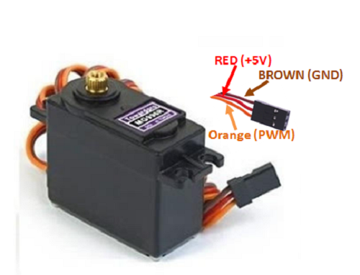

The **MG996R** is a **metal gear servo motor** with a maximum stall torque of 11 kg/cm. Like other RC servos the motor rotates from 0 to 180 degree based on the duty cycle of the PWM wave supplied to its signal pin.

**Wire Configuration**

|  |  |  |
| --- | --- | --- |
| **Wire Number** | **Wire Colour** | **Description** |
| 1 | Brown | Ground wire connected to the ground of system |
| 2 | Red | Powers the motor typically +5V is used |
| 3 | Orange | PWM signal is given in through this wire to drive the motor |

**MG996R Servo Motor Features**

* Operating Voltage is +5V typically
* Current: 2.5A (6V)
* Stall Torque: 9.4 kg/cm (at 4.8V)
* Maximum Stall Torque: 11 kg/cm (6V)
* Operating speed is 0.17 s/60°
* Gear Type: Metal
* Rotation : 0°-180°
* Weight of motor : 55gm
* Package includes gear horns and screws

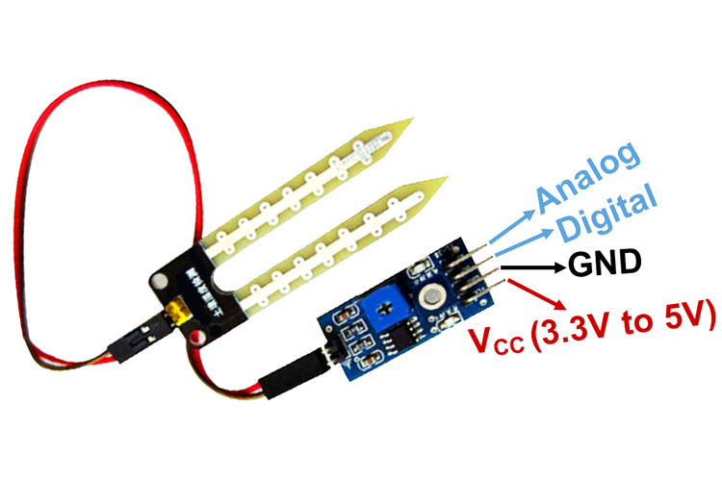

This **soil moisture sensor module** is used to detect the moisture of the soil. It measures the volumetric content of water inside the soil and gives us the moisture level as output. The module has both digital and analog outputs and a potentiometer to adjust the threshold level.

**Soil Moisture Sensor Module Pinout Configuration**

|  |  |
| --- | --- |
| **Pin Name** | **Description** |
| VCC | The Vcc pin powers the module, typically with +5V |
| GND | Power Supply Ground |
| DO | Digital Out Pin for Digital Output. |
| AO | Analog Out Pin for Analog Output |

**Soil Moisture Sensor Module Features & Specifications**

* Operating Voltage: 3.3V to 5V DC
* Operating Current: 15mA
* Output Digital - 0V to 5V, Adjustable trigger level from preset
* Output Analog - 0V to 5V based on infrared radiation from fire flame falling on the sensor
* LEDs indicating output and power
* PCB Size: 3.2cm x 1.4cm
* LM393 based design
* Easy to use with Microcontrollers or even with normal Digital/Analog IC
* Small, cheap and easily available

**Software Details**

1. Diptrace
2. Arduino IDE

**References**

[1] Vijayaragavan S.P., Karthik B., Kiran T.V.U., Sundar Raj M., Robotic surveillance for patient care in hospitals, Middle - East Journal of Scientific Research, v16, i-12, pp-1820-1824, 2013. [2] Vijayaragavan S.P., Karthik B., Kiran Kumar T.V.U., Sundar Raj M., Analysis of chaotic DC-DC converter using wavelet transform, Middle - East Journal of Scientific Research, v-16, i-12, pp-1813-1819, 2013. [3] Sundararajan M., Optical instrument for correlative analysis of human ECG and breathing signal, International Journal of Biomedical Engineering and Technology, v-6, i-4, pp-350-362, 2011. [4] Kiran Kumar T.V.U., Karthik B., Improving network life time using static cluster routing for wireless sensor networks, Indian Journal of Science and Technology, v-6, i-SUPPL5, pp-4642-4647, 2013. [5] Karthik B., Kumar T.K., Dorairangaswamy M.A., Logashanmugam E., Removal of high density salt and pepper noise through modified cascaded filter, Middle - East Journal of Scientific Research, v-20, i-10, pp-1222- 1228, 2014. [6] Karthik B., Kiran Kumar T.V.U., EMI developed test methodologies for short duration noises, Indian Journal of Science and Technology, v-6, i-SUPPL5, pp4615-4619, 2013. [7] Vijayaragavan S.P., Karthik B., Kiran Kumar T.V.U., Privacy conscious screening framework for frequently moving objects, Middle - East Journal of Scientific Research, v-20, i-8, pp-1000-1005, 2014. [8] Vijayaragavan S.P., Karthik B., Kiran Kumar T.V.U., A DFIG based wind generation system with unbalanced stator and grid condition, Middle - East Journal of Scientific Research, v-20, i-8, pp-913-917, 2014. [9] Arul Selvi S., Sundararajan M., A combined framework for routing and channel allocation for dynamic spectrum sharing using cognitive radio, International Journal of Applied Engineering Research, v-11, i-7, pp4951-4953, 2016. [10] Arul Selvi S., Sundararajan M., SVM based two level authentication for primary user emulation attack detection, Indian Journal of Science and Technology, v-9, i-29, pp--, 2016. [11] Kanniga E., Sundararajan M., Kanembedded control of sub cyclic Ac chopperwith high speed and low switching losses, Advanced Materials Research, v-717, i-, pp-579-584, 2013. [12] Kanniga E., Sundararajan M., Modelling and characterization of DCO using pass transistors, Lecture Notes in Electrical Engineering, v-86 LNEE, i-VOL. 1, pp-451-457, 2011. [13] Kanniga E., Selvaramarathnam K., Sundararajan M., Embedded control using mems sensor with voice command and CCTV camera, Indian Journal of Science and Technology, v-6, i-SUPPL.6, pp-4794-4796, 2013. [14] Lakshmi C., Ponnavaikko M., Sundararajan M., Improved kernel common vector method for face recognition, 2009 2nd International Conference on Machine Vision, ICMV 2009, pp-13-17, 2009. [15] Lakshmi C., Sundararajan M., Manikandan P., Hierarchical approach of discriminative common vectors for bio metric security, 2010 The 2nd International Conference on Computer and Automation Engineering, ICCAE 2010, v-2, i-, pp-784-790, 2010.